**Travel Information from Airport to Hotel**

Average travel time is 25-30 min (15,4 km) from the Barcelona Airport ”El Prat” to the Hotel Majestic by car.

**Taxis:**

There are taxi ranks opposite the arrivals areas of each terminal. Taxis are black and yellow. The trip from the airport to the Hotel Majestic should cost approximately 30€.

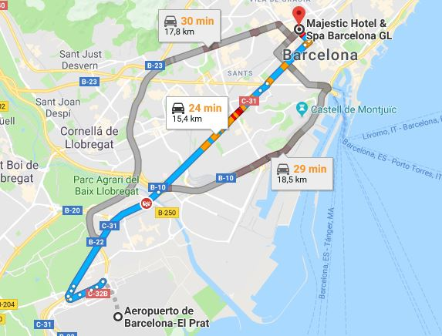

**Majestic Hotel & Spa Barcelona GL**

